10.1.6 Editors - Geometry Node Editor - Header - Add Menu - Attribute
Detailed table of content 1
Add menu 3
Attribute Color Ramp 3
Attribute Compare 5
Attribute Fill 6
Attribute Math 7
Attribute Mix 8
Attribute Proximity 9
Attribute Sample texture 10
Attribute Vector Math 11

Detailed table of content
Detailed table of content
Detailed table of content 1
Add menu 3
Attribute Color Ramp 3
Inputs 4
Geometry 4
Attribute 4
Result 4
Properties 4
Color Ramp 4
Controls 4
+ 4
- 4
Tools menu 4
Flip Color Ramp 4
Distribute Stops from Left 4
Distribute Stops Evenly 4
Eyedropper (pipette icon) E 4
Reset Color Ramp 4
Color Mode 4
RGB 4
HSV/HSL 4
Interpolation 5
Ease 5
Cardinal 5
Linear 5
B-Spline 5
Constant 5
Color Ramp 5
Active Color Stop elements 5
Choose active color stop 5
Pos 5
Outputs 5
Geometry 5
Attribute Compare 5
Inputs 5
Geometry 5
A, B 6
Threshold 6
Result 6
Properties 6
Operation 6
A 6
B 6
Output 6
Geometry 6
Attribute Fill 6
Properties 7
Data Type 7
Inputs 7
Geometry 7
Attribute 7
Value 7
Output 7
Geometry 7
Attribute Math 7
Inputs 7
Geometry 7
Attribute A 7
Attribute B 7
Result 7
Properties 8
Operation 8
Type A 8
Attribute 8
Float 8
Type B 8
Attribute 8
Float 8
Output 8
Geometry 8
Attribute Mix 8
Inputs 8
Geometry 8
A 8
B 8
Result 9
Properties 9
Blending Mode 9
A 9
B 9
Output 9
Geometry 9
Attribute Proximity 9
Inputs 9
Geometry 9
Target 9
Result 9
Properties 10
Target Geometry 10
Outputs 10
Geometry 10
Attribute Sample texture 10
Inputs 10
Geometry 10
Mapping 10
Result 10
Properties 10
Texture property 10
Texture Browser 10
Edit Box 10
Fake User 10
New Texture 11
Remove 11
Outputs 11
Geometry 11
Attribute Vector Math 11
Inputs 11
Geometry 11
A, B, C 11
Result 11
Properties 11
Operation 11
Type A 11
Type B 12
Output 12
Geometry 12

Add menu

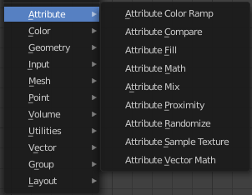
The Attribute menu contains the attribute nodes. These nodes allows you to modify object attributes.

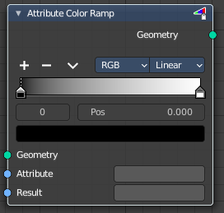
Attribute Color Ramp
Uses a color ramp ot map values from a float attribute to a color attribute of the target geometry.

Inputs

Geometry
Standard geometry input.

Attribute
Name of the attribute that is used as input. It should be a float attribute with values between zero and one.

Result
Name of the attribute where the output is stored. If the attribute does not exist yet, it is created.

Properties

Color Ramp
Color Ramps enables the user to specify a range of colors based on color stops. The color between the color stops gets interpolated.

Controls

+
Add a stop to your color ramp. The stop will be added after the selected one, in the middle to the next one.

-
Deletes the selected color stop from the list.


Tools menu

Flip Color Ramp
Flips the gradient, inverting the values of the color ramp.

Distribute Stops from Left
Rearrange the stops so that every step has the same space to the right.

Distribute Stops Evenly
Space between all neighboring stops becomes equal.

Eyedropper (pipette icon) E
An Eyedropper to sample a color or gradient from the interface to be used in the color ramp.

Reset Color Ramp

Resets the color ramp to its default state.

Color Mode

RGB
Blends color by mixing each color channel and combining.

HSV/HSL
Blends colors by first converting to HSV or HSL, mixing, then combining again. This has the advantage of maintaining saturation between different hues, where RGB would de-saturate, this allows for a richer gradient.


Interpolation

Ease
Uses an Ease Interpolation for the color stops.

Cardinal
Uses a Cardinal Interpolation for the color stops.

Linear
Uses a Linear Interpolation for the color stops.

B-Spline
Uses a B-Spline Interpolation for the color stops.

Constant
Uses a Constant Interpolation for the color stops.

Color Ramp
The color band. A click at one of the color stops makes it the active one. You can move the color stops by clicking at them and dragging them around.

Active Color Stop elements

Adjust the active color stop.

Choose active color stop
Choose the color stop by index.

Pos
The position of the active color stop. The range goes from 0.000 to 1.000

Outputs

Geometry
Standard geometry output.

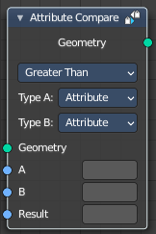
Attribute Compare
This node reads two input attributes as floats and allows for basic element-wise comparison operations. Like the Attribute Math node, it is also possible to switch to using single values for inputs. This node can be combined with the Point Separate node for more flexibility for which points to separate to the second output geometry.

Inputs

Geometry
Standard geometry input.

A, B
The first and second input to the math operation. Depending on the Type input, this is either an attribute name or an input of the specified data type.

Threshold
Shows with method Equal and Not Equal. This value is used as a threshold for still considering the two inputs as equal.

Result
Name of the attribute where the computed result it stored. If an attribute with this name does not exist yet, a new attribute with a Boolean data type is added. If it does exist, the values of the existing attribute are overridden.

Properties

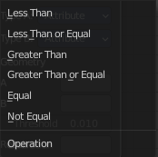
Operation
The math function to use.
Note! For operations besides Equal and Not Equal, the input attributes are converted implicitly to the float data type. For the equality operations on vectors, the distance between the vector inputs is used.

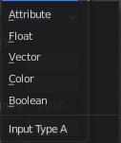
A
Input type A for the corresponding socket.

B
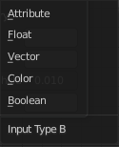
Input type B for the corresponding socket.

Output

Geometry
Standard geometry output.

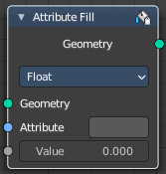
Attribute Fill
The Attribute Fill node sets the value for every element of the attribute with the input name to the input value. If the attribute doesn’t exist yet, it will be created.

Properties

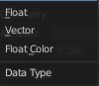
Data Type
The type of data to fill the attribute with.

Inputs

Geometry
The geometry that is modified.

Attribute
The name of the attribute to fill with the value.

Value
A value of the data type to fill the attribute with.

Output

Geometry
The same geometry as the input with a modified attribute.

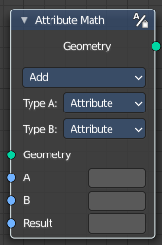
Attribute Math
Modify an attribute with a math operation.

Inputs

Geometry
Standard geometry input.

Attribute A
The first input to the math operation. This can be either an attribute name or numeric value.

Attribute B
The second input to the math operation. This can be either an attribute name or numeric value.

Result
Name of the attribute where the computed result it stored. A new attribute with that name is added, if it does not exist yet. If it does exist, the existing attribute is overridden.

Properties

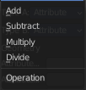
Operation
The math function to perform.
Note! Attributes are converted implicitly to the float data type.

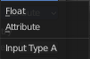
Type A

Attribute
The input is a text field that expects an attribute name.

Float
The input is a number field.

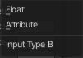
Type B

Attribute
The input is a text field that expects an attribute name.

Float
The input is a number field.

Output

Geometry
Standard geometry output.

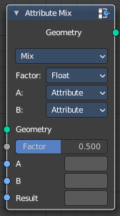
Attribute Mix
Mix attributes to creates to create a new attribute.

Inputs

Geometry
Standard geometry input.

A
The first input to the mix operation. This can be an attribute name or a value.
Result

B
The second input to the mix operation. This can be an attribute name or a value.

Result
Name of the attribute where the computed result is stored. The output attribute type is Color by default. When the result attribute exists already, its type is not changed.

Properties

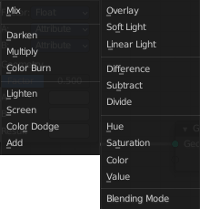
Blending Mode
Operation that is performed on the inputs.

A
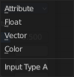
Input type A for the corresponding socket.

B
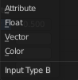
Input type B for the corresponding socket.

Output

Geometry
Standard geometry output.

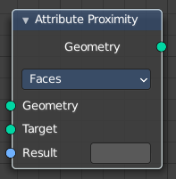
Attribute Proximity
Not documented yet.

Inputs

Geometry
Standard geometry input.

Target
Name of the attribute to fill with random values. If there is no attribute with the given name, a new one is created.

Result
Name of the attribute where the output is stored. If the attribute does not exist yet, it is created.

Properties

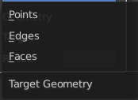
Target Geometry
The element of the target geometry to calculate the distance from.

Outputs

Geometry
Standard geometry output.

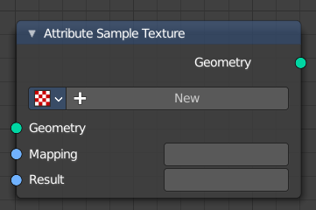
Attribute Sample texture
The Attribute Sample Texture node evaluates a texture for every point, and stores the resulting colors in a new attribute. The mapping attribute can be anything that can be converted to a 3D vector. For example the name of a uv map or the position attribute is used.
Note that UV maps can only be accessed after a Point Distribute node currently. This is a limitation that will be resolved.

Inputs

Geometry
Standard geometry input.

Mapping
Name of the attribute that is used as input. It should be a float attribute with values between zero and one.

Result
Name of the attribute where the output is stored. If the attribute does not exist yet, it is created.

Properties

Texture property

The texture to use.

Texture Browser
A list of the available textures.

Edit Box
The name of the current active texture. Click to edit.

Fake User
Assign a fake user to this texture so that it is not removed when closing Bforartists.

New Texture
Add a new texture.

Remove
Remove the texture. This sets the texture inactive. It is still in the texture list.

Outputs

Geometry
Standard geometry output.

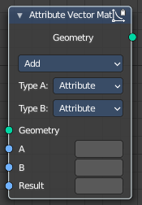
Attribute Vector Math
Modify an attribute with a math operation.

Inputs

Geometry
Standard geometry input.

A, B, C
The inputs to the math operations. Depending on the operation one, two, or all three of the inputs will be used. The attribute types are all vectors of three values, except for the Scale operation, where the second input uses a float type.

Result
The name of the attribute where the computed result it stored. A new attribute with that name is added if it does not exist yet. If it does exist, the values of the existing attribute are overridden.

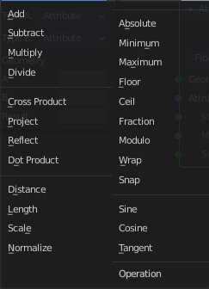
Properties

Operation
The available vector math operations. The methods should be self explaining.
Note that attributes are converted implicitly to the input data type.

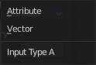
Type A
Input type A for the corresponding socket.

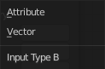
Type B
Input type B for the corresponding socket.

Output

Geometry
Standard geometry output.

